Training: Wisconsin Special Education Mediation System’s Dispute Resolution Options

Wednesday,
November 13, 2013
CESA # 12 Conference Center
Location: 618 Beaser Ave.
Ashland, WI 54806

Time: 5:00-7:00, Dinner included

Presented By:
Nissan Bar-Lev, Special Education Director, CESA 7

Jan Serak
Executive Co-Director,
WI FACETS

Target Audience:
- Parents
- Special Education Directors
- Principals
- School Psychologists
- Special Education Teachers
- Counselors
- DPL’s & CPL’s

Sponsored By:
Regional Service Network & WI Statewide Parent Educator Network

Standards: P4, P5, P6, T10

Indicators: 16

It is important for parents and school staff to resolve any issues right away – before issues fester and negatively impact their relationship.

Learn how the Wisconsin Special Education Mediation System (WSEMS) can help with early dispute resolution. This workshop includes information about free WSEMS services for mediation, facilitated IEPs and resolution meetings; when to use each option; how to make a request; who are the mediators and facilitators; related federal and state laws; and more.

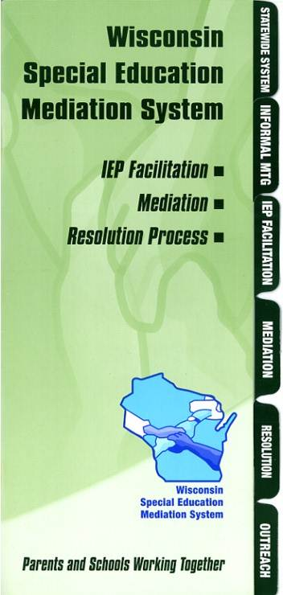

This is a free event being offered by WSEMS. This professional development opportunity is also being supported through funding from the IDEA Discretionary Grant #14-74-9911-IDEA10-CFDA #84.027.

To Register, go to:
www.myquickreg.com
Questions? Contact

Jerianne Kvapil, 715-682-2363, jerianne@cesa12.org
Evelyn Azbel, 715-820-1667, evelyna@cesa12.org

